Microsoft Outlook: Set up for iPhone and Android devices
Official URL: https://services.smsu.edu/TDClient/180/Portal/KB/Article/3988/Microsoft-Outlook-Set-up-for-iPhone-and-Android-devices
Category: Knowledge Base > Information Technology Services > Software and Applications > Microsoft Outlook: Set up for iPhone and Android devices
Tags: microsoft, email, outlook, iphone, android
_____________________________________________________

How to setup your SMSU email on your iPhone or Android
This guide is designed for students, faculty and staff who will like to setup their student email on their personal device (iPhone or Android phone) for easy access.
Please note that this guide has been written using an iPhone X, but the screens will vary slightly depending on the device you have.
- You will need to download and install the Microsoft Outlook application from Google play store or Apple store
- Please open Outlook App.
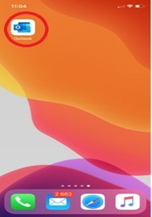
Figure 1: Screenshot
- Next, enter your starid@go.minnstate.edu (students) or starid@minnstate.edu (faculty/staff) and click Add account.
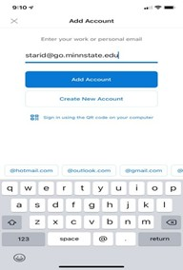
Figure 2: Screenshot
- Next, please type your password and click “Sign In”
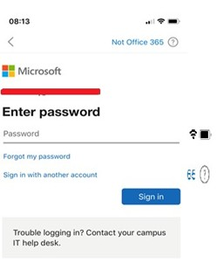
Figure 3: Screenshot
- Next please use the code that should be sent to your phone number to verify your identity and click verify.
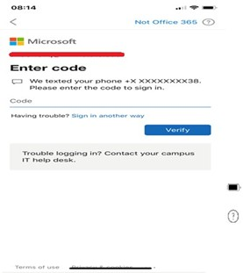
Figure 4: Screenshot

How to disable Focused inbox and Organized by Thread
- Open your Outlook app inbox
- Touch on the image box to the left of inbox in the upper left-hand corner • Touch the gear icon (Settings)
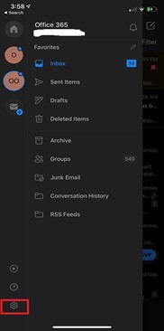
Figure 5: Screenshot
- Scroll down and turn off both Focused inbox and Organized By Thread
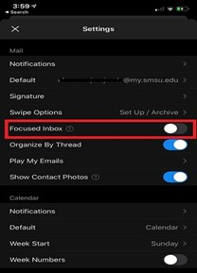
Figure 6: Screenshot
- If you want to set up your signature, touch the signature option to create one or you can copy and paste a signature that you already have into the text area.
- If you sync your phone contact to your work email, in settings, under accounts touch starid@go.minnstate.edu (students) or starid@minnstate.edu (faculty/staff)and then look for sync contacts and turn it on.
If you are having any difficulty setting your e-mail up, please contact the Technology Resource Center Helpdesk by email (TRC@smsu.edu) or by phone, at 507-537-6111
Accessibility Review & Update Log:
- [x] Content accuracy and link integrity verified
- [x] High-contrast visual hierarchy implemented (Inter and Calibri)
- [x] Image alt-text captions verified (all screenshots captioned)
- [x] PDF attachments scraped and fully inlined directly inside the document
- [x] Outline headers and standard list sequences optimized for screen readers

